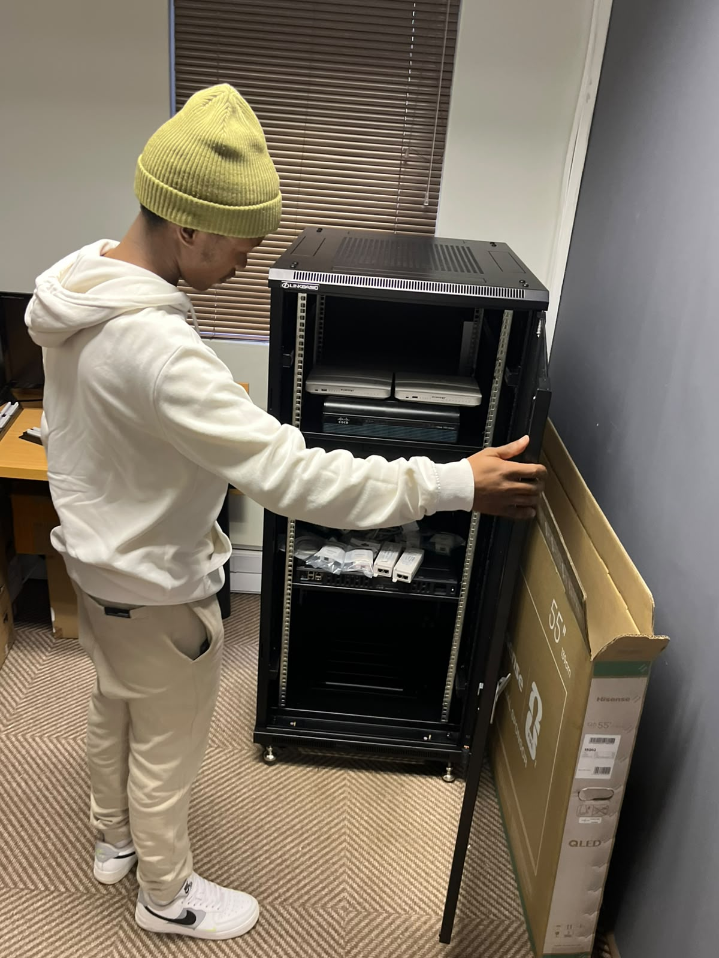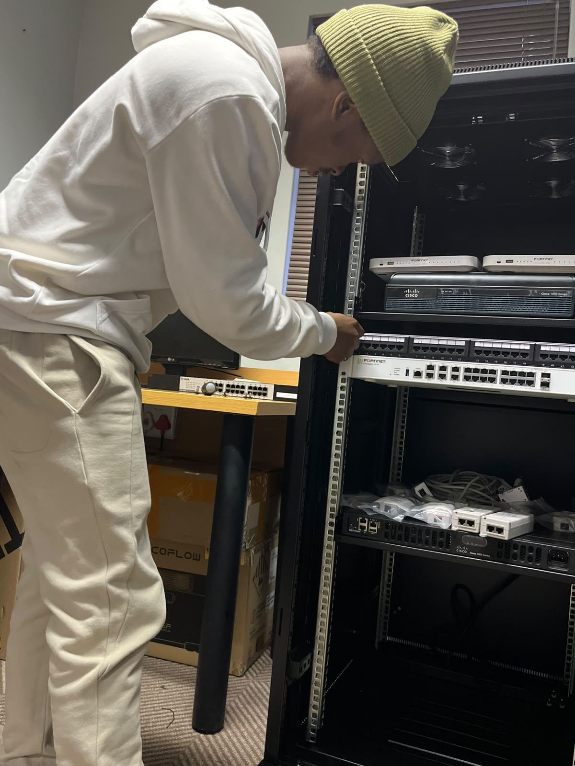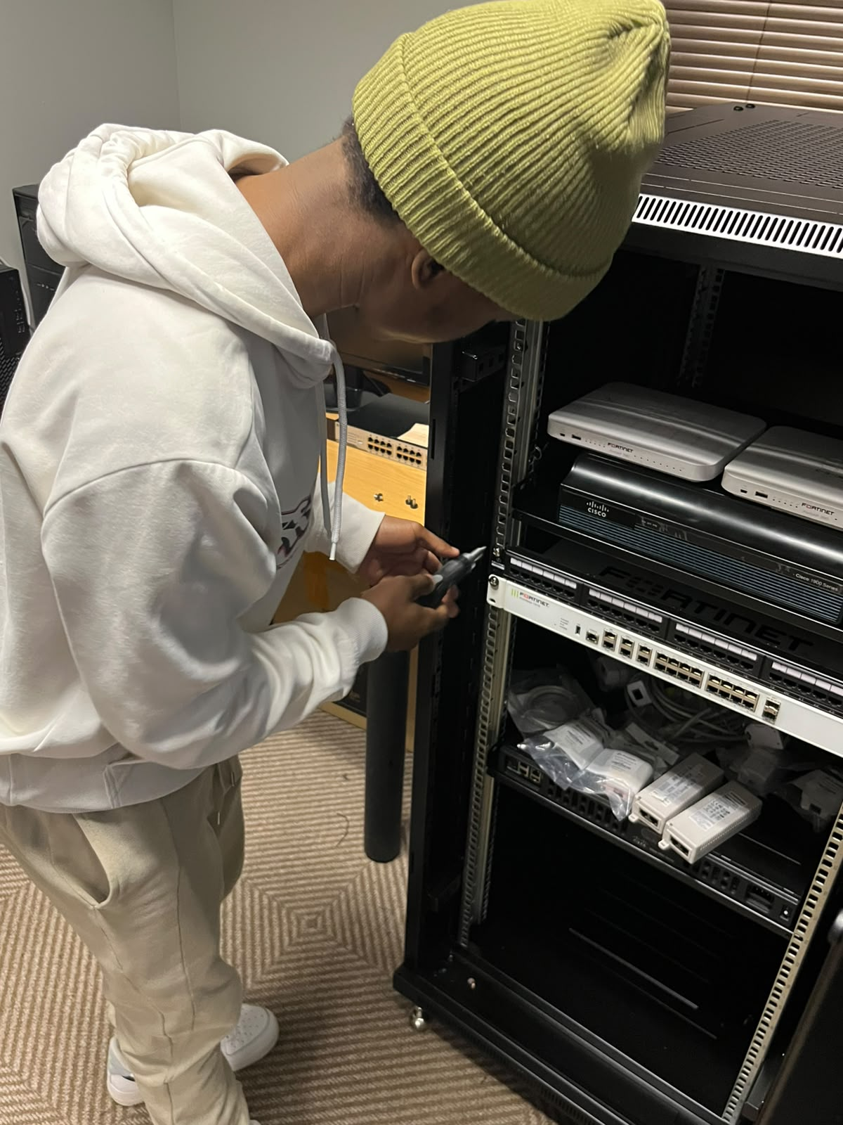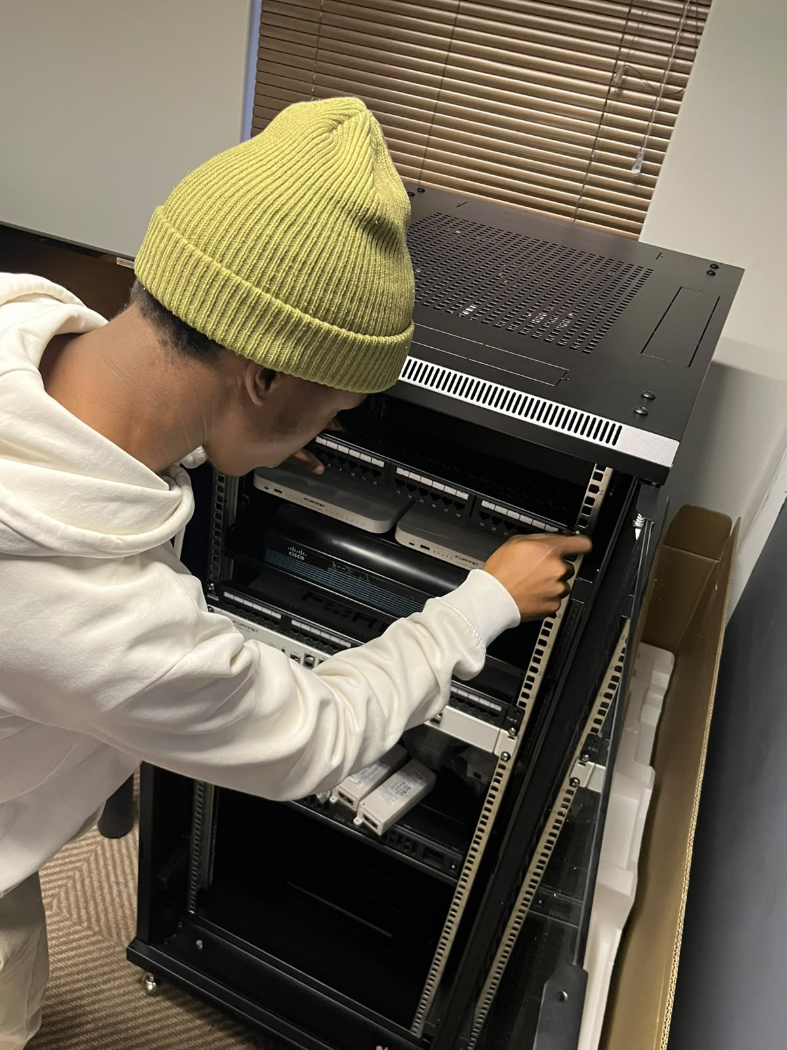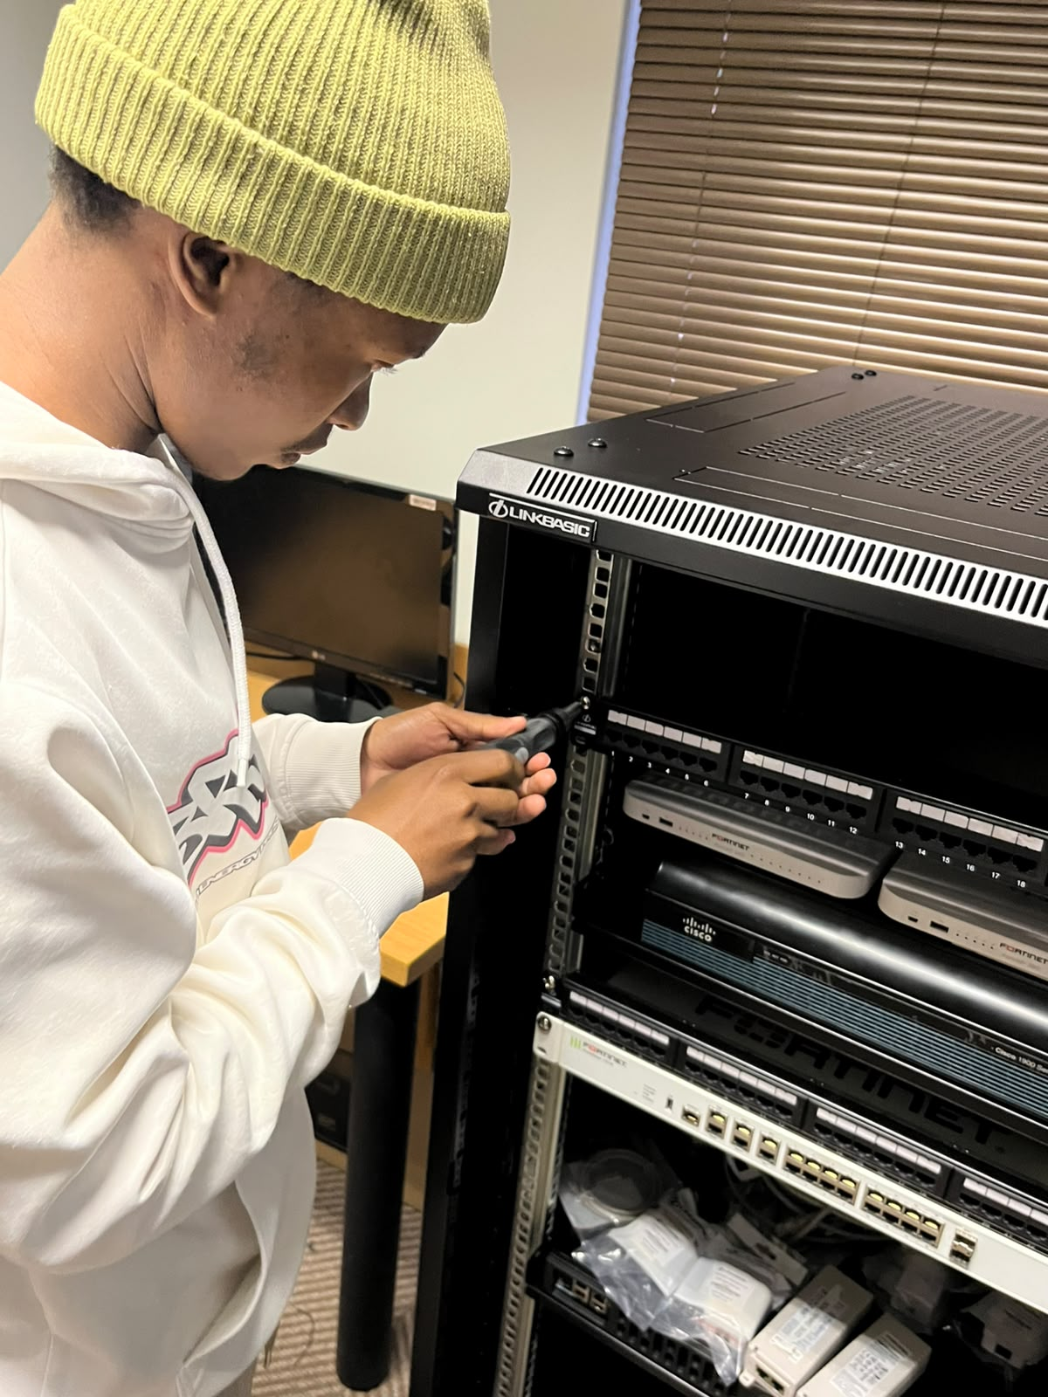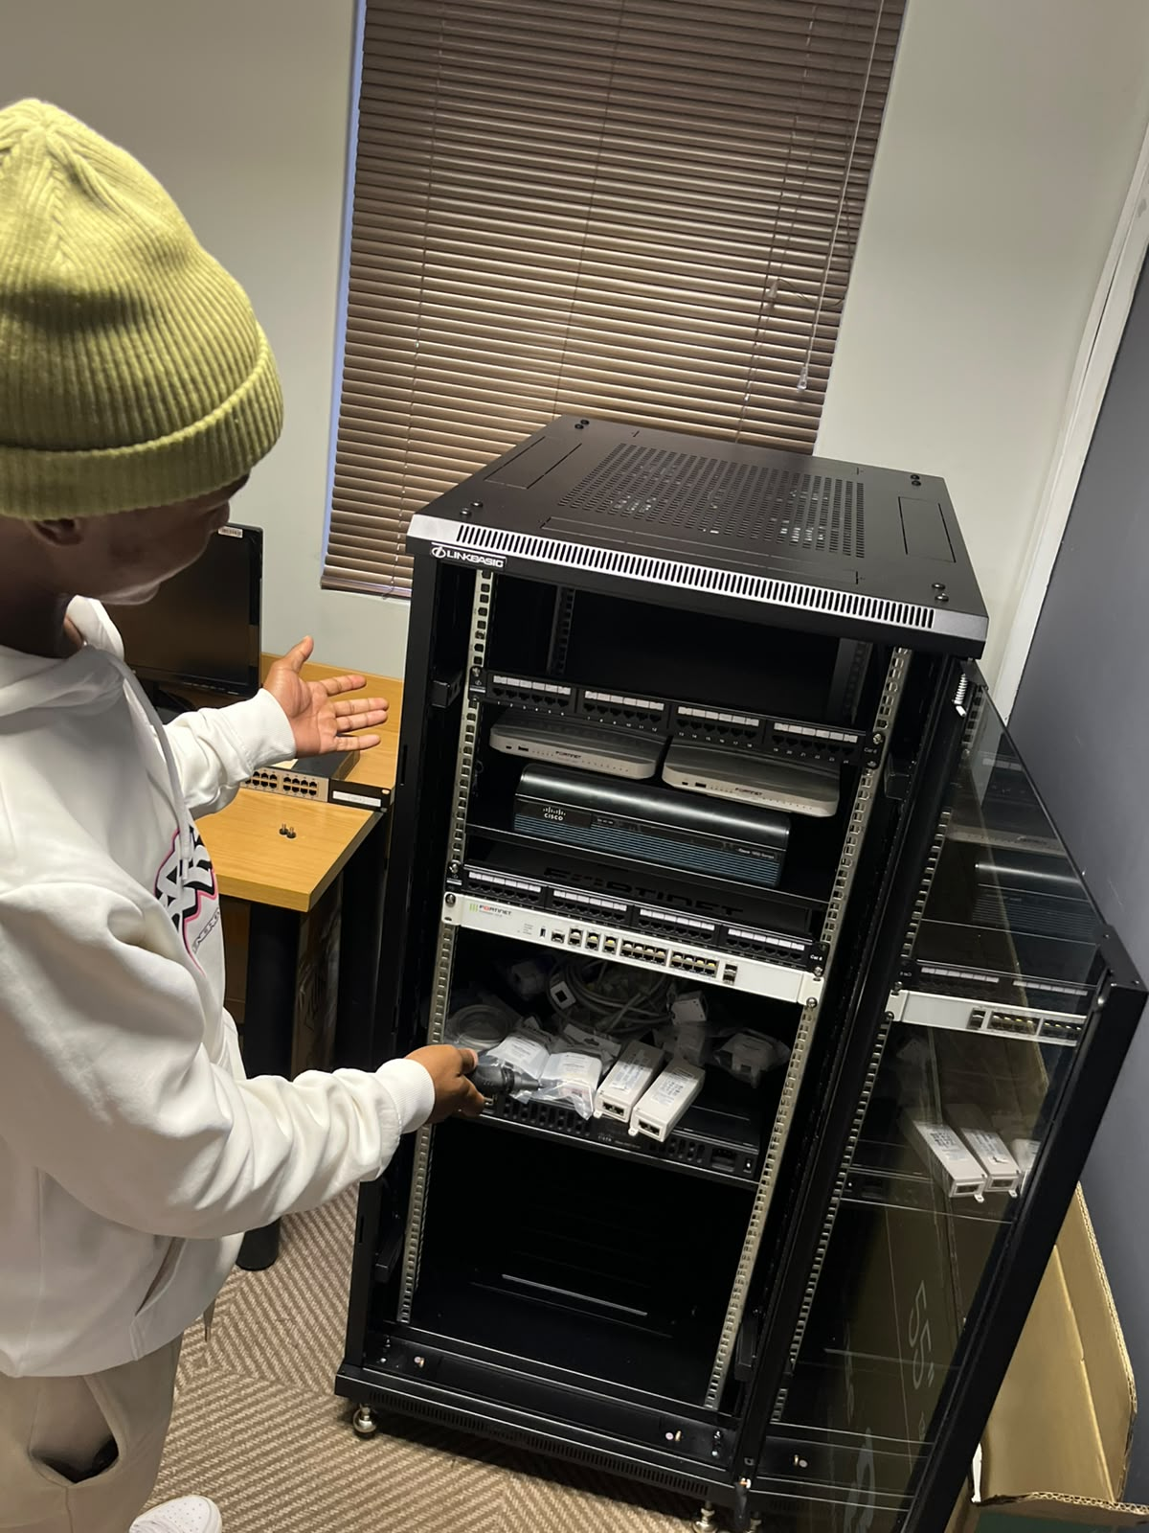

What is a patch panel and what does it do?
Patch panels are the ultimate tool for network organization. It serves as a central point where all cables can be neatly labelled and laid out. Patch panels are how network administrators avoid tangled knots of CAT5 cable across the Local Area Network shack. A patch panel serves as a centralized point for organizing and managing multiple network cables, which allows for efficient connectivity and easy reconfiguration of devices in a network setup. They also provide an excellent way to decouple the actual patching of cables from the expensive hardware used to route data. Furthermore, it enhances cable management, simplifies troubleshooting, and provides documentation and traceability for all workstations.

